**Level 3. Implementasi Next Js dan Tailwind Css Dasar**

**Tampilan Login:**

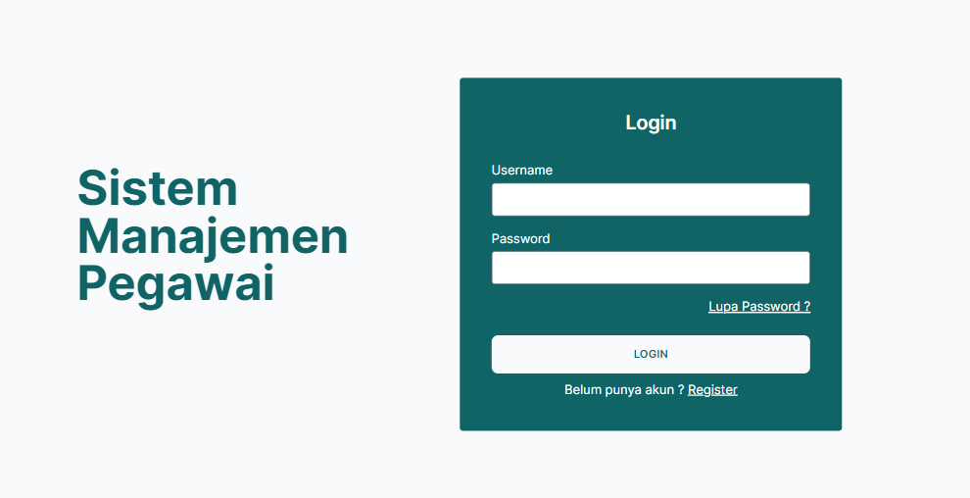

**Tampilan Register:**

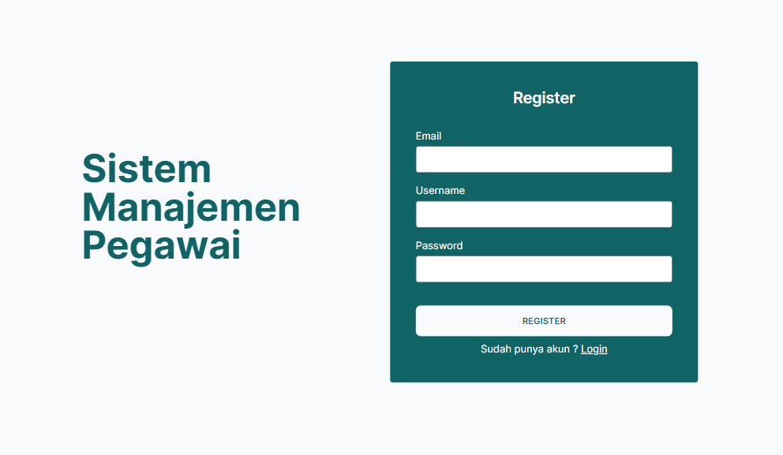

**Tampilan Forgot Password:**



**Tampilan list, add, update, detail, delete data karyawan:**

1. **List**

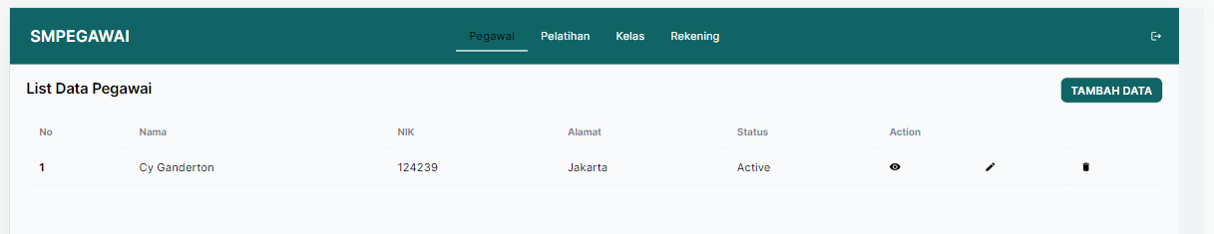

1. **Add**

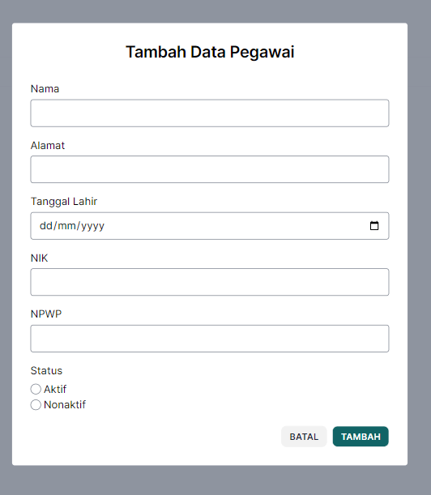

1. **Update**

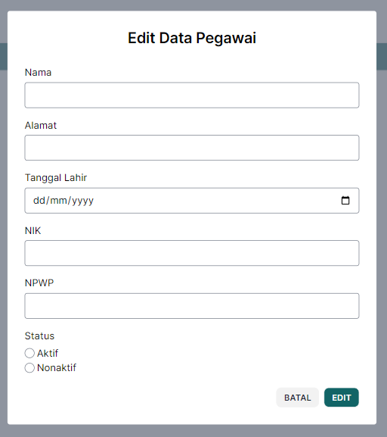

1. **Detail**

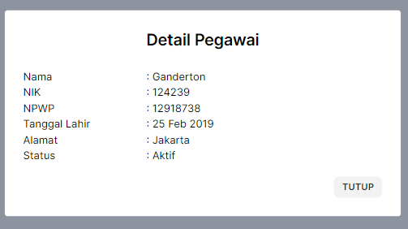

1. **Delete**

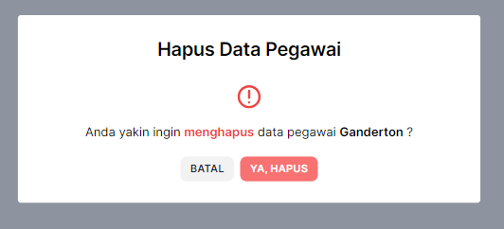

**Tampilan list, add, update, detail, delete data karyawan training:**

1. **List**

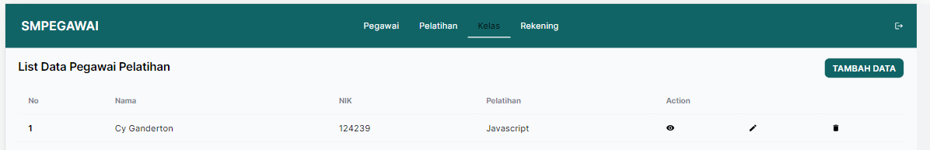

1. **Add**

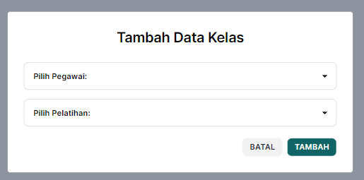

1. **Update**

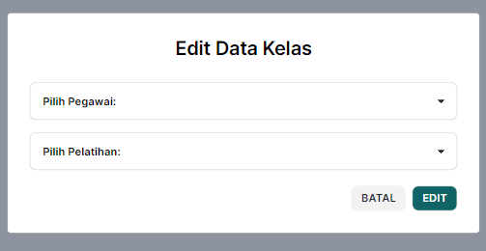

1. **Detail**

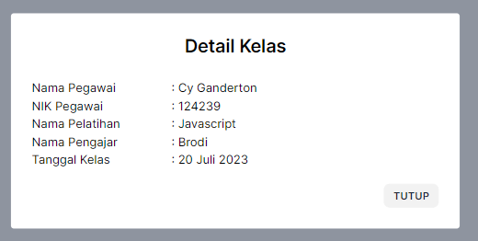

1. **Delete**

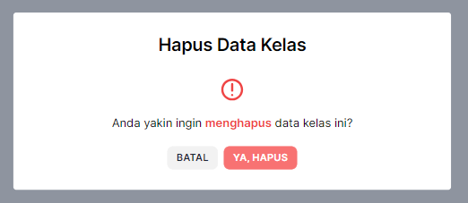

**Tampilan list, add, update, detail, delete data training:**

1. **List**

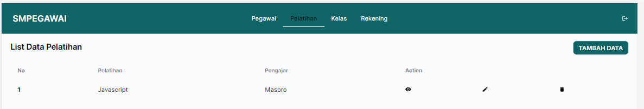

1. **Add**

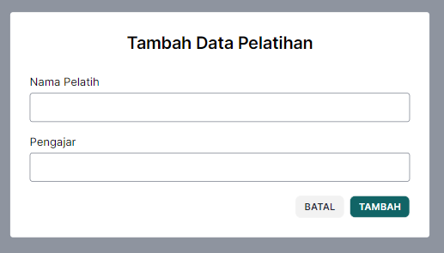

1. **Update**

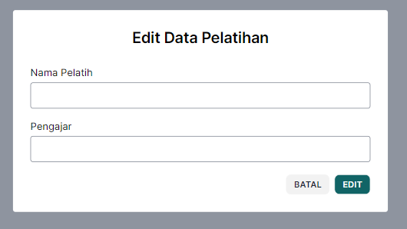

1. **Detail**

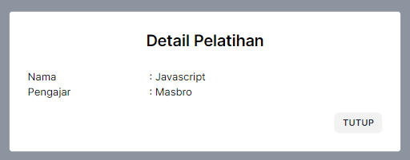

1. 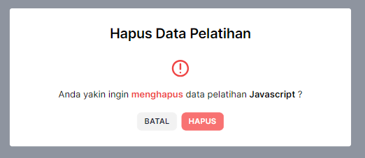**Delete**

**Tampilan list, add, update, detail, delete data rekening:**

1. **List**

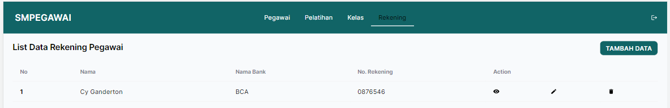

1. **Add**

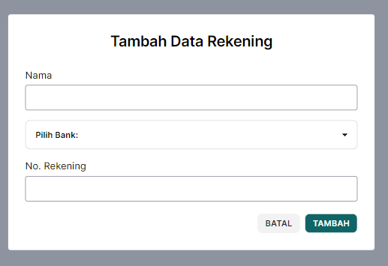

1. **Update**

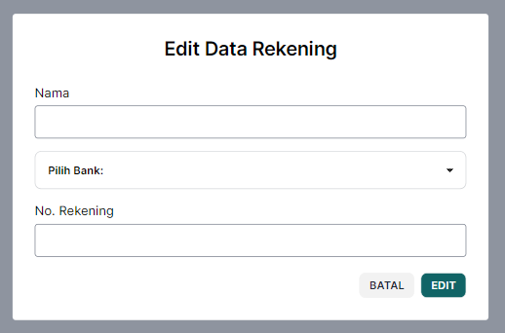

1. **Detail**

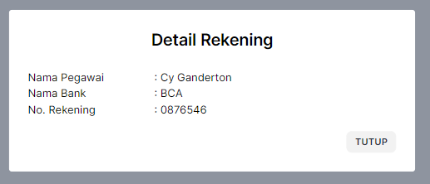

1. **Delete**

